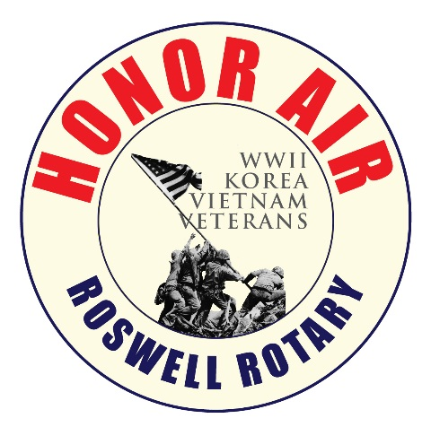 **Roswell Rotary Honor Air April 9th 2025 Itinerary**

**5:00 am:** Guardians & Volunteers arrive

**5:15 am: VETERANS** Arrive at Roswell Area Park. Boarding passes, name lanyards etc. distributed. Board buses

**6:00 am:** Buses Depart Roswell Park for ATL

**7:00 – 8:00 am:** Arrive at airport. Clear security and board airplane

**9 am: American Airlines Flight _____** departs Atlanta to Reagan National Airport (DCA) Note: Continental breakfast served on board flight

**10:30 am:** Flight arrives at DCA. Deplane aircraft and board buses

**11:30 pm – 1:00 pm: We will have a boxed lunch first on the bus,** then visit the World War II Memorial. **Announce group photo to be taken at the Georgia column at 12:30.**

**1:00 – 3:15 pm:** Depart World War II Memorial for a tour of Viet Nam Veterans, Korean Veterans and Lincoln Memorials.

**3:15** Proceed to Arlington National Cemetery with a bus stop at the Iwo Jima Memorial.

**4:00 pm:** Permission to enter *Arlington National Cemetery* with a stop *at The Tomb of the Unknown Soldier* to view the 5 pm ceremony of the Changing of the Guard.

**5:45 pm:** Board the coaches for the drive back to DCA Reagan Airport

**6:00 pm:** Arrive DCA Regan; disembark busses, check in - security processing.

**7:00 pm:** Wheels up out of Reagan (DCA) **American Airlines Flight ______**. Dinner served on board flight

**8:30 pm:** Arrival in ATL

**9:30 pm:** Board coach buses for Roswell Park with an ETA of **10:15 - 10:30** Arrival at Roswell Park. **Family and volunteers should plan to be there at 9:30 pm.**