FOR HONOR FLIGHT USE ONLY Last Name: _______________________________ Date Received: ______ /______ /______
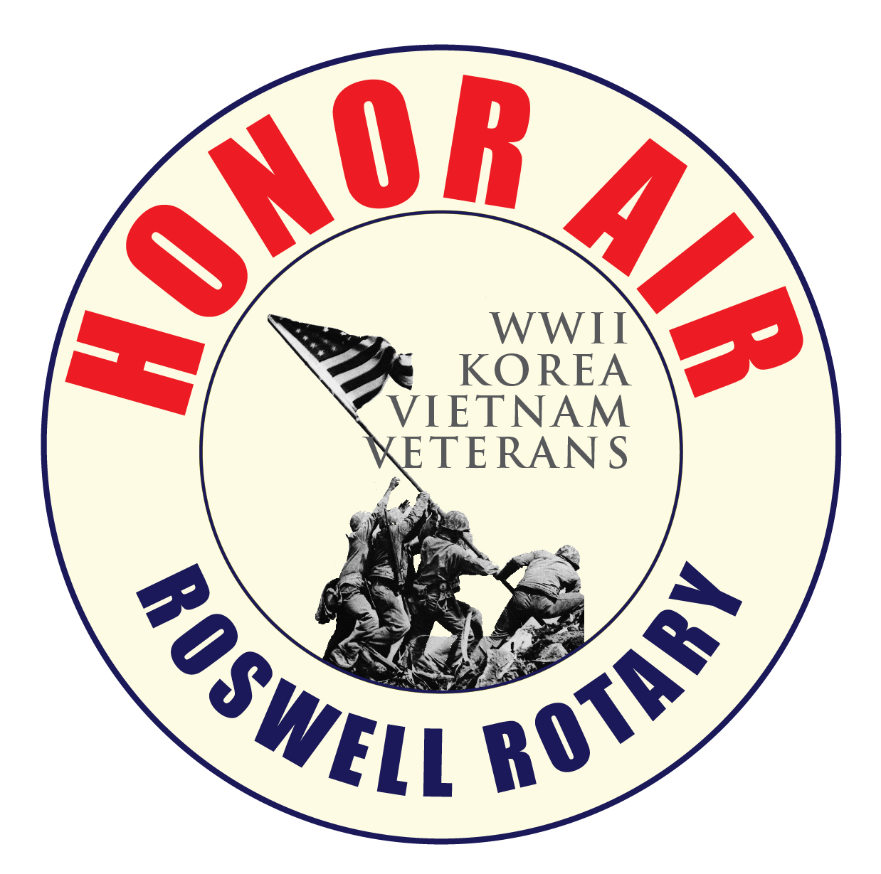Guardian Application ~ April 9th 2025
Roswell Rotary Honor Air would not be successful without the generous support of our guardians. Guardians play a significant role on every trip, ensuring that every veteran has a safe and memorable experience. Duties include, but not limited to, physically assisting the veterans at the airport during the flight and at the memorials. Guardians are also responsible for their own expenses (airline fare, etc.). Guardians must be at least 18 years old. Training of guardians will be provided for this position. You can also visit us at www.roswellrotary.club/honor-air. Thank You for your support.
NAME:________________________________________________________ NICKNAME:____________________________________
(As it appears on your ID for airline travel) (If applicable)
ADDRESS:__________________________________________________________________CITY:______________________________ STATE: __________ ZIP CODE: __________ E-MAIL ADDRESS: ______________________________________________________
PHONE: DAY: _____________________ EVENING: ___________________ MOBILE: ___________________ DOB: ___________
OCCUPATION:__________________________________________________ T-Shirt Size: (S, M, L, XL, XXL, XXXL) ________ ARE YOU A VETERAN? YES NO If a veteran, please indicate BRANCH of service, and WHEN and WHERE you served: ________________________________________ _______________________________________________________________________________________________________________ How did you learn about the Roswell Rotary Honor Air organization? _______________________________________________________ Why are you volunteering for Honor Flight? ___________________________________________________________________________
Have you ever been on an Honor Flight trip? ___________________________________________________________________________
Please list any prior volunteer experience or special skills you have: _________________________________________________________ _______________________________________________________________________________________________________________ Please note any medical experience you may have (e.g., EMT, CPR, Paramedics): _____________________________________________
Please list one (1) personal reference:
Name: ________________________________________________________ Relationship to applicant: ___________________________
Address: ______________________________________________________ City: __________________ State: ________ Zip: ________
E-Mail Address: ________________________________________________ Phone: Day: _______________Evening: ________________
Please list one (1) emergency contact:
Name: ________________________________________________________ Relationship to applicant: ____________________________
Address: ______________________________________________________ City: __________________ State: ________ Zip: ________
E-Mail Address: ________________________________________________ Phone: Day: _______________Evening: ________________

Please identify any physical disabilities, restrictions and or medical conditions that would limit your ability to fulfill the duties of guardian: _______________________________________________________________________________________________________
_______________________________________________________________________________________________________

Also, please list any medications being taken and how often: ______________________________________________________
_______________________________________________________________________________________________________

PLEASE REVIEW CAREFULLY AND SIGN:
The undersigned acknowledges and agrees that:
1. As photographic and video equipment are frequently used to memorialize and document Roswell Rotary Honor Air trips and events, his/her image may appear in a public forum, such as the media or a website, to acknowledge, promote or advance the work of the Roswell Rotary Honor Air program. I hereby release the photographer and Roswell Rotary Honor Air from all claims and liability relating to said photographs I hereby give permission for my images captured during Roswell Rotary Honor Air activities through video, photo, or other media, to be used solely for the purposes of Roswell Rotary Honor Air promotional material and publications, and waive any rights or compensation or ownership thereto.
2. I further state that medical insurance is the responsibility of the guardian and I understand that Roswell Rotary Honor Air does NOT provide medical care. I understand that I accept all risks associated with travel and other Roswell Rotary Honor Air activities and will not hold Roswell Rotary Honor Air responsible for any injuries incurred by me while participating in the Roswell Rotary Honor Air program.

3. I understand that ALL of my expenses of $450.00 are MY responsibility, are non-refundable and are to be paid in advance.

4. You can also sponsor a veteran and pay for yourself for the special price of $911. Please consider this as a way to enjoy the day and to give back to these amazing men and women. ** Please indicate if you are choosing this option: ______________________ Veterans name you are sponsoring: _________________

SIGNED: ____________________________________________________ DATE: __________________
(E-mail applicants will be required to sign prior to actual trip date)
Please submit this form to:
Roswell Rotary Honor Air
ATTN: Guardian Application
PO Box 783
Roswell, GA 30076
E-mail to: AHUGHES@WSNIELSEN.COM
Phone: 678-283-7098
Fax :770-475-8116
Website: www.roswellrotary.club/honor-air

