FOR ROSWELL ROTARY HONOR AIR USE ONLY Last Name: _______________________________ Date Received: __________
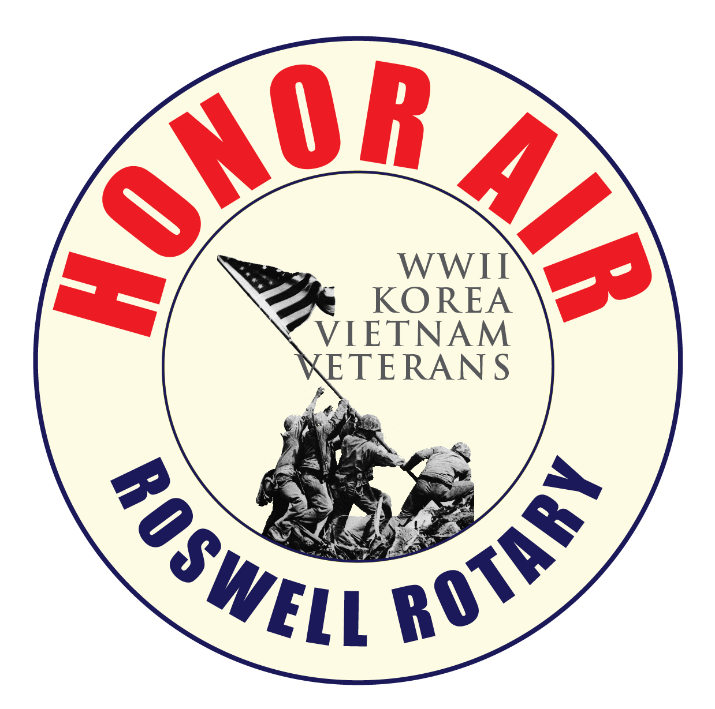Veteran Application ~ April 9th 2025
Roswell Rotary Honor Air recognizes American veterans for your sacrifices and achievements by flying you to Washington, DC to see YOUR memorial at no cost. Top priority (for which we are currently accepting applications) is given to WWII and terminally ill veterans from all wars. In order for Roswell Rotary Honor Air to achieve this goal, guardians fly with the veterans on every flight providing assistance and helping veterans have a safe, memorable and rewarding experience. For what you and your comrades have given to us, please consider this a small token of appreciation from all of us at Roswell Rotary Honor Air. This flight is only open to veterans who have NEVER flown on an Honor Air Flight. You can also visit us at www.roswellrotary.club/honor-air
YOUR NAME: __________________________________________________________________ NICKNAME: __________________________
(As it appears on your ID for airline travel) (If Applicable)
ADDRESS: _____________________________________________________________________________________________________________ CITY: ____________________________________________ STATE: _________ ZIP: ____________WEIGHT: _________ DOB: ____________
PHONE: Day: _________________________ Evening: ___________________________ Mobile: _____________________________________
E-MAIL ADDRESS: _____________________________________________________ T- SHIRT S1ZE: (S, M, L, XL, XXL, XXXL): ________
HOW DID YOU HEAR ABOUT ROSWELL ROTARY HONOR AIR FLIGHT?______________________________________________________
ARE YOU A MEMBER OF A ROTARY CLUB?________________________________
HAVE YOU VISITED THE D.C. MEMORIALS PREVIOUSLY_________________________________
HAVE YOU EVER BEEN ON AN HONOR AIR FLIGHT?___________________________________
SERVICE HISTORY: BRANCH OF SERVICE: __________________ RANK: ___________________ YEAR DISCHARGED: ____________
HOME TOWN (from which city and state did you enter the service?):_______________________________________________________________
WHICH WAR?: ______________________________ ACTIVITY DURING THE WAR:___________________________________ _______________________________________________________________________________________________________________________ WOULD YOU BE WILLING TO FURNISH A PICTURE OF YOURSELF DURING THE SERVICE (will be returned)? _____________________
ALTERNATE CONTACT: (son, daughter, etc): NAME: ________________________________________________________________________
PHONE NOS.: _______________________________ E-MAIL:____________________________________ RELATIONSHIP:________________
EMERGENCY CONTACT INFORMATION: (someone available the day you travel):
NAME: ___________________________________________________________________ RELATIONSHIP: ____________________________ ADDRESS:____________________________________________________________________________________________________________
PHONE: Day: ________________________ Evening: ________________________ Mobile: ________________________ Other: ____________
MEDICAL: INFORMATION PROVIDED WILL NOT DISQUALIFY YOU. IT PERMITS US TO ASSESS THE SUPPORT WE NEED DURING THE TRIP. INFO IS FOR HONOR FLIGHT AND MEDICAL PERSONNEL ONLY.
Do you use mobility equipment? YES NO. If YES, please circle device: CANE WALKER WHEELCHAIR SCOOTER
MEDICATIONS (name and how often you take it):
MEDICATION TAKEN HOW OFTEN? MEDICATION TAKEN HOW OFTEN?
________________________ ______________________ ________________________ ______________________
________________________ ______________________ ________________________ ______________________
________________________ ______________________ ________________________ ______________________
________________________ ______________________ ________________________ ______________________
________________________ ______________________ ________________________ ______________________
Do you have any drug allergies? YES NO. If YES, please list: _______________________________________________________
___________________________________________________________________________________________________________

Please complete NEXT page

Are you a cardiac patient? YES _________NO__________ Do you carry nitroglycerin? YES _________NO __________
Do you have a history of seizure? YES NO. Please describe what type (i.e. grand mal, petitmal,other):______________________
When was your last seizure? ____________ If within past 5 years. STRONGLY advised you discuss trip with your private physician!
Do you have problems with motion sickness (sea or air)? YES NO. If yes, is it controlled with medications? YES NO. If motion sickness is not controlled with medications, it is STRONGLY advised you discuss the trip with your private physician!
Do you have any breathing problems? YES NO. If YES, please describe: ____________________________________________ Do you use a home nebulizer machine? YES NO. If YES, you are STRONGLY encouraged to discuss the trip with your private physician concerning the use of portable hand-held nebulizers during the trip.
Do you use oxygen at any time? YES NO. If YES, you will need your private physician to write a prescription for oxygen to be used during the flight and during the tour. Oxygen will be provided. The prescription should be turned in with the application.
Do you have a problem walking the length of a football field without assistance? YES NO. If yes, please describe the reason (e.g. lung problems, arthritis, heart problems, knee or hip problems, etc.): ___________________________________________________
Do you have a history of open head injuries, sinus problems, or ear problems? YES NO. If YES, have you flown since the open head injury, sinus or ear problems occurred? YES NO. If YES, did you have any problems? YES NO. If YES, it is STRONGLY advised you discuss the trip with your private physician. If you have NEVER flown since the open head injury, sinus or ear problems, again we STRONGLY advise you discuss the trip with your private physician!
Do you have a urostomy or colostomy bag? YES NO. If YES, please make sure the bag is vented prior to flight. If you do not know if your bag is vented, it is STRONGLY advised that you discuss this issue with your private physician!
Do you have diabetes? YES NO. If YES, do you take insulin? YES NO. If YES, you are STRONGLY encouraged to discuss the trip with your private physician concerning the use of insulin during the trip!
Do you have any special dietary needs? YES NO. If YES, PLEASE describe: ________________________Additional Comments or Concerns: ___________________________________________________________________________________________________________
PLEASE REVIEW CAREFULLY AND SIGN:
The undersigned acknowledges and agrees that:
1. As photographic and video equipment are frequently used to memorialize and document Roswell Rotary Honor Air trips and events, his/her image may appear in a public forum, such as the media or a website, to acknowledge, promote or advance the work of the Roswell Rotary Honor Air program. I hereby release the photographer and Roswell Rotary Honor Air from all claims and liability relating to said photographs. I hereby give permission for my images captured during Roswell Rotary Honor Air activities through video, photo, or other media, to be used solely for the purposes of Roswell Rotary Honor Air promotional material and publications, and waive any rights or compensation or ownership thereto.
2. I further state that medical insurance is the responsibility of the veteran and I understand that Roswell Rotary Honor Air does NOT provide medical care. I understand that I accept all risks associated with travel and other Roswell Rotary Honor Air activities and will not hold Roswell Rotary Honor Air responsible for any injuries incurred by me while participating in the Roswell Rotary Honor Air program.
SIGNED: ___________________________________________________ DATE: ________________ (E-mail applicants will he required to sign prior to actual flight date)
Please submit this form to: Roswell Rotary Honor Air
ATTN: Veteran Application
PO Box 783
Roswell, GA 30076
Or fax to: 770-475-8116
Or e-mail to: AHUGHES@WSNIELSEN.COM
Phone: 678-283-7098

